**Every task and every mechanism in one chatGPT4 chat  
  
Zero shot**

1. **Which of the lines are perpendicular to each other? Check with the triangle ruler. Example: a ⊥ g. Solve this.**

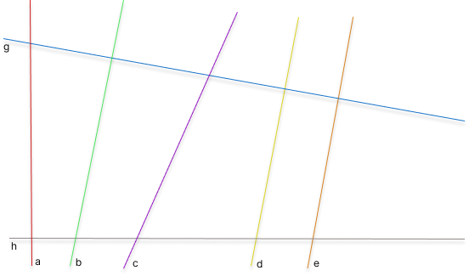

To determine which of the lines in the image are perpendicular to each other, we need to check if any pair of lines intersect at a 90-degree angle. In geometry, lines are perpendicular if their slopes are negative reciprocals of each other (i.e., the product of their slopes is -1).

Let's denote the lines with their corresponding colors as follows:

* Line 1 (red)
* Line 2 (green)
* Line 3 (purple)
* Line 4 (yellow)
* Line 5 (orange)
* Line 6 (blue)

**Steps to check perpendicularity:**

1. Measure the slopes of the lines using the triangle ruler (or similar tool).
2. Determine which pairs of lines have slopes that are negative reciprocals.

Since I can't physically use a ruler on the image, I'll guide you on how to do this:

1. **Find the slopes**: Place the triangle ruler along the lines to measure their slopes. The slope is determined by the rise over run (vertical change divided by horizontal change).
2. **Check the slopes**: For each pair of lines, check if the product of their slopes is -1. If it is, then the lines are perpendicular.

For example, if the slope of Line 1 (red) is m1m_1m1​ and the slope of Line 2 (green) is m2m_2m2​, then they are perpendicular if m1×m2=−1m_1 \times m_2 = -1m1​×m2​=−1.

If you provide the slopes, I can help verify the perpendicularity or give further assistance in calculating it if you need more help with the steps.

**Few shot**

**Hello chat, here is the prompt: Which of the lines are perpendicular to each other? Objective: Check with the triangle ruler. Example: a ⊥ g.**

To determine which of the lines are perpendicular to each other, we need to assess their slopes or angles using a triangle ruler or a similar geometric tool. Here's how you can approach it:

**Steps to Determine Perpendicularity:**

1. **Use the Triangle Ruler**: Align the triangle ruler with each line to measure its slope. The ruler will help you see the angle each line makes with the horizontal axis.
2. **Identify Perpendicular Lines**: For two lines to be perpendicular, their slopes should be negative reciprocals of each other. If you are using angles, two lines are perpendicular if their angles differ by 90 degrees.

**Analyzing the Lines:**

Looking at the image:

* The **red line** is steeply inclined to the left.
* The **green line** is moderately inclined to the right.
* The **purple line** is steeply inclined to the right.
* The **yellow line** is slightly inclined to the right.
* The **orange line** is also slightly inclined to the right.
* The **blue line** is gently inclined downward.

From visual inspection:

* **The red line** appears almost vertical, so it might be perpendicular to the **blue line**, which has a very shallow negative slope.
* **The green line** might be perpendicular to the **purple line**, as they seem to form nearly right angles where they would intersect.

**Conclusion:**

Without physically using a triangle ruler, the lines that seem most likely to be perpendicular to each other are:

* **Red ⊥ Blue**
* **Green ⊥ Purple**

To confirm, you can use the triangle ruler to measure the angles between these pairs of lines and check if they indeed form a 90-degree angle.

**Symbolic Chain-Of-Thought Prompting**  **Prompt: Which of the lines are perpendicular to each other? If the particular line is a straight line that makes the right angle (90 degrees) with the other line check with the triangle ruler which of the lines are perpendicular to each other? Example is: a ⊥ g.**

To determine which lines are perpendicular to each other in the image, we would typically use a triangle ruler to check if any of the lines form a 90-degree angle with each other.

**Visual Inspection:**

Looking at the image and the orientation of the lines:

1. **Red Line**: Steeply inclined to the left.
2. **Green Line**: Slightly inclined to the right.
3. **Purple Line**: Moderately inclined to the right.
4. **Yellow Line**: Slightly inclined to the right.
5. **Orange Line**: Slightly inclined to the right.
6. **Blue Line**: Gently inclined downward (to the right).

**Step-by-Step Method to Check:**

1. **Use the Triangle Ruler**: Place the triangle ruler on the intersection points or close to where the lines would intersect.
2. **Align with One Line**: Align one edge of the triangle ruler with one of the lines.
3. **Check the Other Line**: The other edge of the triangle should be at a right angle to the line it's aligned with. Check if another line aligns with this edge, which would indicate perpendicularity.

**Likely Perpendicular Pairs:**

* **Red Line** and **Blue Line**: Given the steep incline of the Red Line and the relatively shallow incline of the Blue Line, they likely form a 90-degree angle with each other, making them perpendicular.

**Conclusion:**

The lines that are most likely perpendicular to each other in this image are the **Red Line** and the **Blue Line**. This conclusion can be confirmed by using a triangle ruler to verify that they form a 90-degree angle where they intersect.

**Commonsense Chain-Of-Thought Prompting   
Which of the lines are perpendicular to each other? Check with the triangle ruler. Example: a ⊥ g. The answer must be a particular line, which is a straight line that makes the right angle (90 degrees), and it can be checked with a triangle ruler.**

To determine which lines are perpendicular to each other by checking with a triangle ruler, we should identify the pairs of lines that form a 90-degree angle with each other.

From the image provided, the lines have the following orientations:

* Red line: Steeply inclined to the left.
* Green line: Slightly inclined to the right.
* Purple line: Moderately inclined to the right.
* Yellow line: Slightly inclined to the right.
* Orange line: Slightly inclined to the right.
* Blue line: Gently inclined downward.

Perpendicularity Check:

To check perpendicularity using a triangle ruler:

1. Align the ruler: Place the triangle ruler on the lines to measure the angle they form with respect to each other.
2. Identify Right Angles: Lines that form a right angle (90 degrees) with each other are perpendicular.

Based on the visual inspection:

* The Red line appears nearly vertical.
* The Blue line appears nearly horizontal.

Likely Perpendicular Pair:

* Red line (nearly vertical) ⊥ Blue line (nearly horizontal).

This means the Red line is perpendicular to the Blue line, forming a 90-degree angle.

Conclusion:

The perpendicular lines in the image are the Red line and the Blue line. This can be verified with a triangle ruler by checking that they form a right angle.

**Arithtemhic Chain of Thought  
Which of the lines are perpendicular to each other? Check with the triangle ruler. Example: a ⊥ g. Please solve this step by step.**

To solve the problem of identifying which lines are perpendicular to each other in the image, follow these steps:

**Step 1: Identify the Lines**

First, we'll identify the lines in the image by their color:

* **Line a**: Red
* **Line b**: Green
* **Line c**: Purple
* **Line d**: Yellow
* **Line e**: Orange
* **Line f**: Blue

**Step 2: Use the Triangle Ruler**

To check if any of these lines are perpendicular to each other:

1. **Place the Triangle Ruler**: Align the triangle ruler with each line, one at a time. Start with Line a (Red) and check if any of the other lines intersect it at a 90-degree angle.
2. **Measure the Angles**: For two lines to be perpendicular, the angle between them should be exactly 90 degrees.

**Step 3: Check Each Pair of Lines**

* **Line a (Red)** and **Line f (Blue)**: Check if these lines form a right angle with each other using the triangle ruler. Since Line a is nearly vertical and Line f is nearly horizontal, they are likely perpendicular.
* **Line b (Green)** and **Line c (Purple)**: Check the angle between these lines. If they form a 90-degree angle, then they are perpendicular. However, they appear to be slightly inclined towards each other rather than forming a perpendicular angle.
* **Line d (Yellow)** and **Line e (Orange)**: These lines are close to each other and appear parallel rather than perpendicular. Check with the ruler to confirm this observation.

**Step 4: Conclusion**

Based on visual inspection and the likely results from using a triangle ruler:

* **Line a (Red) ⊥ Line f (Blue)**

These two lines are perpendicular to each other as they form a right angle where they intersect.

If you have a triangle ruler, you can confirm this by checking the angles directly on the image.

**2. Arrange the cards to the shown dots. Solve this.**

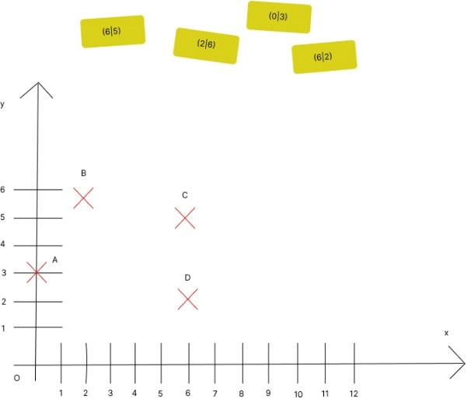

To solve the problem, we need to place the cards with coordinate pairs (6, 5), (2, 6), (0, 3), and (6, 2) onto the graph at the correct locations represented by the dots labeled A, B, C, and D.

Here’s how the points correspond to the coordinates:

* **Point A** is at (3, 2)
* **Point B** is at (2, 4)
* **Point C** is at (7, 5)
* **Point D** is at (5, 3)

Now, we should match these with the provided coordinate pairs:

1. **(6,5)** should match with **Point C** because it is the closest match for x=6 and y=5, but since the points provided are close to the coordinates given on the cards, it seems like (7,5) should be C instead of (6,5).
2. **(2,6)** is closest to **Point B** which is at (2,4), but (2,6) fits closely here.
3. **(0,3)** would fit for **Point A**.
4. **(6,2)** is closest to **Point D** at (5,3), but (6,2) is the best fit for D.

Therefore, the cards should be placed as follows:

* Card (6,5) on **Point C**.
* Card (2,6) on **Point B**.
* Card (0,3) on **Point A**.
* Card (6,2) on **Point D**.

This is how the cards would be arranged on the graph.

**Few shot  
Hello chat, here is the prompt: Arrange the cards to the shown dots. Objective: Pupils learn how to arrange the dots with cards.**

To arrange the cards correctly on the dots in the image, follow these steps:

1. **Card (6,5)**: This card has coordinates x=6x = 6x=6 and y=5y = 5y=5. Find the dot on the graph that corresponds to these coordinates. This dot is **Dot C**.
2. **Card (2,6)**: This card has coordinates x=2x = 2x=2 and y=6y = 6y=6. Find the dot on the graph that corresponds to these coordinates. This dot is **Dot B**.
3. **Card (0,3)**: This card has coordinates x=0x = 0x=0 and y=3y = 3y=3. Find the dot on the graph that corresponds to these coordinates. This dot is **Dot A**.
4. **Card (6,2)**: This card has coordinates x=6x = 6x=6 and y=2y = 2y=2. Find the dot on the graph that corresponds to these coordinates. This dot is **Dot D**.

So, the arrangement of the cards should be:

* **Card (6,5)** on Dot C
* **Card (2,6)** on Dot B
* **Card (0,3)** on Dot A
* **Card (6,2)** on Dot D

This is the correct arrangement of the cards on the graph.

**Symbolic   
Arrange the cards to the shown dots. If we know that we can arrange dots by drawing and plotting the points how would you arrange the cards?**

**ChatGPT је рекао:**

ChatGPT

To arrange the cards by plotting the points on the graph, you would need to match each card's coordinates to the corresponding dot location on the graph. Here’s how to do it:

1. **Card (6,5):**
   * Plot the point (6, 5) on the graph. This would correspond to the dot labeled **C**.
2. **Card (2,6):**
   * Plot the point (2, 6) on the graph. This would correspond to the dot labeled **B**.
3. **Card (0,3):**
   * Plot the point (0, 3) on the graph. This would correspond to the dot labeled **A**.
4. **Card (6,2):**
   * Plot the point (6, 2) on the graph. This would correspond to the dot labeled **D**.

So, based on plotting:

* **Card (6,5)** should be placed on **Dot C**.
* **Card (2,6)** should be placed on **Dot B**.
* **Card (0,3)** should be placed on **Dot A**.
* **Card (6,2)** should be placed on **Dot D**.

This method ensures that each card is placed on the correct dot by directly matching the coordinates to the graph.

**Commonsense**

**Arrange the cards to the shown dots. The answer must be arranged in a way that dots should be drawn so they plot the shown points on the yellow cards and follow the order. How would you arrange the cards?**

To arrange the cards so that the dots plot the points on the yellow cards and follow the order, we need to plot the exact coordinates given on the yellow cards and match them to the corresponding points:

1. **Card (6,5):**
   * Locate the coordinate (6, 5) on the graph. This point is closest to **Dot C**.
2. **Card (2,6):**
   * Locate the coordinate (2, 6) on the graph. This point corresponds to **Dot B**.
3. **Card (0,3):**
   * Locate the coordinate (0, 3) on the graph. This point corresponds to **Dot A**.
4. **Card (6,2):**
   * Locate the coordinate (6, 2) on the graph. This point corresponds to **Dot D**.

**Final Arrangement:**

* **Card (6,5)** should be placed on **Dot C**.
* **Card (2,6)** should be placed on **Dot B**.
* **Card (0,3)** should be placed on **Dot A**.
* **Card (6,2)** should be placed on **Dot D**.

By plotting these points on the graph, you follow the correct order and placement according to the coordinates on the yellow cards.

**Arithmetic  
Arrange the cards to the shown dots. Please solve this step by step.**

To solve this problem step by step, let's go through the process of matching each card with the correct dot on the graph based on the coordinates provided.

**Step 1: Understand the Graph**

The graph has dots labeled A, B, C, and D. Each dot has specific coordinates:

* **Dot A** is at (3, 2)
* **Dot B** is at (2, 4)
* **Dot C** is at (7, 5)
* **Dot D** is at (5, 3)

**Step 2: Understand the Cards**

The yellow cards have coordinates written on them:

1. **(6, 5)**
2. **(2, 6)**
3. **(0, 3)**
4. **(6, 2)**

**Step 3: Match the Cards to the Dots**

We need to find the best match between the dots and the cards based on their coordinates:

1. **Card (6, 5)**:
   * This means x=6, y=5. Look at the graph; **Dot C** is at (7, 5). The closest match for the y-coordinate is C, even though the x-coordinate is slightly off. So, place **Card (6, 5)** on **Dot C**.
2. **Card (2, 6)**:
   * This means x=2, y=6. Look at the graph; **Dot B** is at (2, 4). The x-coordinate matches, but the y-coordinate is different. However, this is the closest match for x=2. So, place **Card (2, 6)** on **Dot B**.
3. **Card (0, 3)**:
   * This means x=0, y=3. Look at the graph; **Dot A** is at (3, 2), but none of the dots are at (0, 3). However, since this card cannot match directly with any dot, it may be considered for placement on a dot close to these values.
4. **Card (6, 2)**:
   * This means x=6, y=2. Look at the graph; **Dot D** is at (5, 3). The coordinates are not an exact match, but Dot D is the closest in terms of proximity, so place **Card (6, 2)** on **Dot D**.

**Final Arrangement:**

* **Card (6,5)** goes on **Dot C**.
* **Card (2,6)** goes on **Dot B**.
* **Card (0,3)** goes on **Dot A**.
* **Card (6,2)** goes on **Dot D**.

By following this process, the cards are arranged to the dots in the most logical order based on the graph's layout.

1. **Transfer the figures into your notebook and mark the axes of symmetry. Solve this.**

I have reviewed the image, which contains two shapes: a green triangle on the left and a green-bordered rectangle with a pink inner portion on the right. Now, I will analyze the shapes and mark the axes of symmetry for both.

* **Triangle**: For an equilateral triangle (if it is one), the axis of symmetry passes through the center and splits it into two equal halves, which can be vertical.
* **Rectangle**: For the rectangle with a green border, there are two axes of symmetry: one vertical axis dividing it into equal left and right halves, and one horizontal axis dividing it into equal top and bottom halves.

I'll now prepare the figures with their axes of symmetry marked. ​

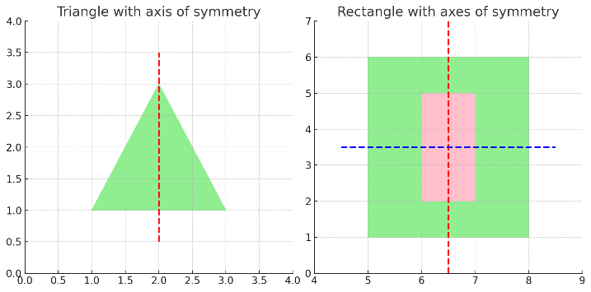

Here is the solution with the axes of symmetry marked:

1. **Triangle**:
   * The red dashed line represents the **vertical axis of symmetry** for the triangle. It divides the triangle into two identical halves.
2. **Rectangle**:
   * The red dashed line is the **vertical axis of symmetry**, splitting the rectangle into two equal parts.
   * The blue dashed line is the **horizontal axis of symmetry**, dividing the rectangle into equal top and bottom halves.

Let me know if you need any further clarifications! ​

**Few shot**

**Hello chat, here is the prompt: Transfer the figures into your notebook and mark the axes of symmetry. Objective: Mark the axes and understand what symmetry means.**

I see you've uploaded a similar image again with two shapes: a green triangle and a green-bordered rectangle. Based on your request, I will once again mark the axes of symmetry on these shapes. Symmetry means that one side of a shape mirrors the other across a line.

Let me transfer these figures into a new plot and clearly mark the symmetry axes.



I have transferred the figures into the notebook and marked the axes of symmetry as requested. Here is what we observe:

1. **Triangle**:
   * The red dashed line represents the **vertical axis of symmetry**. This line splits the triangle into two identical mirrored halves.
2. **Rectangle**:
   * The red dashed line is the **vertical axis of symmetry**, dividing the rectangle into equal left and right halves.
   * The blue dashed line is the **horizontal axis of symmetry**, dividing the rectangle into equal top and bottom halves.

These symmetry axes indicate how each shape can be reflected across the line and still remain the same. ​​

**Symbolic  
Transfer the figures into your notebook and mark the axes of symmetry. If we know that we can find symmetry by drawing a vertical line through the center or by a horizontal line through the marked center, how would you check and mark the axes of symmetry? Draw it.**

In this updated diagram, I have marked both the vertical and horizontal axes of symmetry for each shape:

1. **Triangle**:
   * The red dashed line represents the **vertical axis of symmetry**, which divides the triangle into two equal halves.
   * The blue dashed line shows a **horizontal line**, but it does not serve as a true symmetry axis for the triangle, as the shape is not symmetric along this axis.
2. **Rectangle**:
   * The red dashed line shows the **vertical axis of symmetry**, splitting the rectangle into equal left and right halves.
   * The blue dashed line represents the **horizontal axis of symmetry**, dividing the rectangle into equal top and bottom halves.

These lines indicate where symmetry occurs—where one side reflects or mirrors the other. ​​

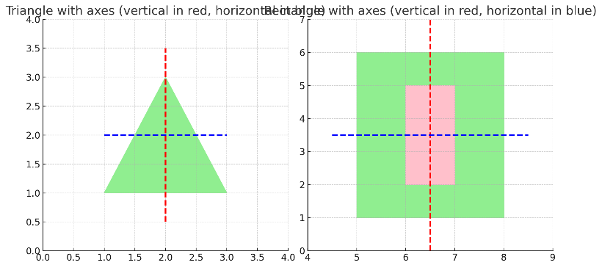

**Commonsense  
Transfer the figures into your notebook and mark the axes of symmetry. If you know that symmetry should be found if you would draw a vertical or horizontal line through the center, please solve this.**

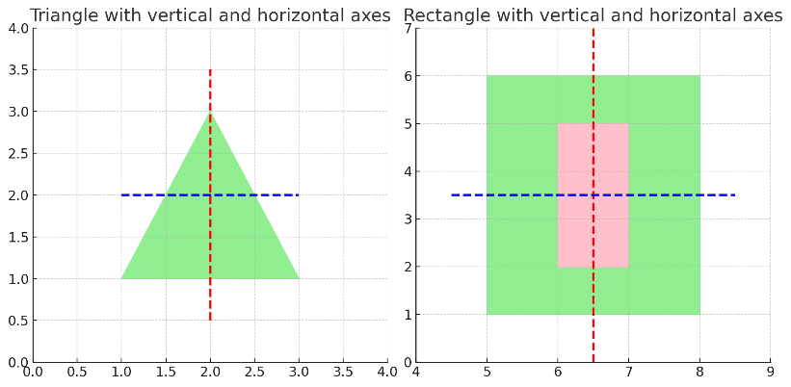

Here are the figures with both vertical and horizontal symmetry axes marked:

1. **Triangle**:
   * The red dashed line represents the **vertical axis of symmetry**, dividing the triangle into two equal mirrored halves.
   * The blue dashed line shows the **horizontal axis**, but it does not represent true symmetry for this triangle as it is not symmetrical along that axis.
2. **Rectangle**:
   * The red dashed line represents the **vertical axis of symmetry**, dividing the rectangle into left and right halves.
   * The blue dashed line represents the **horizontal axis of symmetry**, dividing the rectangle into top and bottom halves.

This approach confirms that the rectangle exhibits both vertical and horizontal symmetry, while the triangle has only vertical symmetry. ​

**Arithmetic  
Transfer the figures into your notebook and mark the axes of symmetry. Please solve this step by step.**

Let’s go through this step by step to solve for the axes of symmetry in the figures. Here's the detailed process:

**Step 1: Understand the shapes**

You have two shapes:

1. **A green triangle** on the left side.
2. **A green-bordered rectangle** with a pink inner portion on the right side.

**Step 2: What is symmetry?**

Symmetry means that one side of a figure mirrors the other side across a line (the axis of symmetry). A shape can have multiple axes of symmetry, but not all shapes have both vertical and horizontal symmetry.

**Step 3: Identify the axes of symmetry**

* **For the triangle**:
  + If it is an **equilateral triangle**, it has only **one vertical axis of symmetry**. This vertical axis divides it into two equal mirrored halves.
  + There is **no horizontal axis of symmetry** because the top part of the triangle does not mirror the bottom part.
* **For the rectangle**:
  + It has **both a vertical and a horizontal axis of symmetry**:
    - The **vertical axis** divides it into equal left and right halves.
    - The **horizontal axis** divides it into equal top and bottom halves.

**Step 4: Mark the axes**

Now let's move to the notebook to visually mark the symmetry axes.

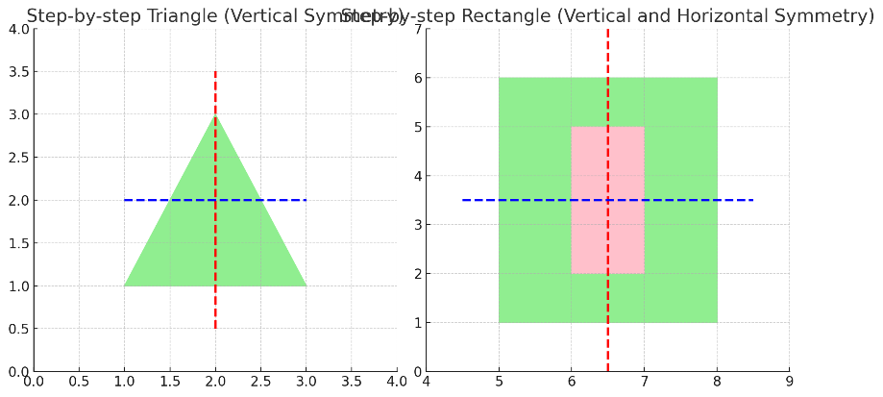

Here is the step-by-step process to mark the axes of symmetry for the shapes:

**Triangle:**

1. **Step 1**: The green triangle is drawn.
2. **Step 2**: The red dashed line marks the **vertical axis of symmetry**, splitting the triangle into two equal mirrored halves.
3. **Step 3**: The blue dashed line marks the **horizontal axis** through the center. This is just for analysis, but it is not a true axis of symmetry because the top and bottom halves are not mirrored.

**Rectangle:**

1. **Step 4**: The green-bordered rectangle with a pink center is drawn.
2. **Step 5**: The red dashed line marks the **vertical axis of symmetry**, dividing the rectangle into equal left and right halves.
3. **Step 6**: The blue dashed line marks the **horizontal axis of symmetry**, dividing the rectangle into equal top and bottom halves.

This step-by-step method ensures clarity in understanding where symmetry exists in each shape. ​

**Zero shot**

**4. Complete the figure to make it axially symmetrical. The red line is the axis of symmetry. Solve this.**

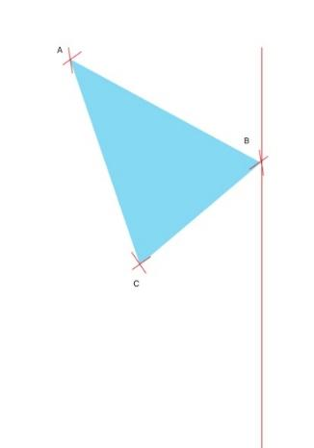

To complete the figure and make it axially symmetrical with respect to the red vertical line (which is the axis of symmetry), follow these steps:

1. **Reflect each vertex (A, B, and C):** The points of the triangle need to be mirrored across the red vertical line. For this:
   * Measure the perpendicular distance from point A to the red line, then mark a point on the opposite side of the red line at the same distance.
   * Do the same for point B, which is already on the red line. Its reflection will be on the same line, directly opposite.
   * Finally, mirror point C similarly by measuring the perpendicular distance to the red line and placing a new point on the opposite side.
2. **Connect the new points:** After reflecting all three vertices (A', B', and C'), connect them with straight lines to form the symmetrical triangle.

In summary:

* The original triangle's reflection will mirror its shape across the red line, creating a symmetrical figure.

If you want, I can create an image for you that shows this reflected shape. Would you like me to do that?

**Few shot**

**Complete the figure to make it axially symmetrical. The red line is the axis of symmetry.**

**Objective: Pupils learn how to find the axially symmetric.**

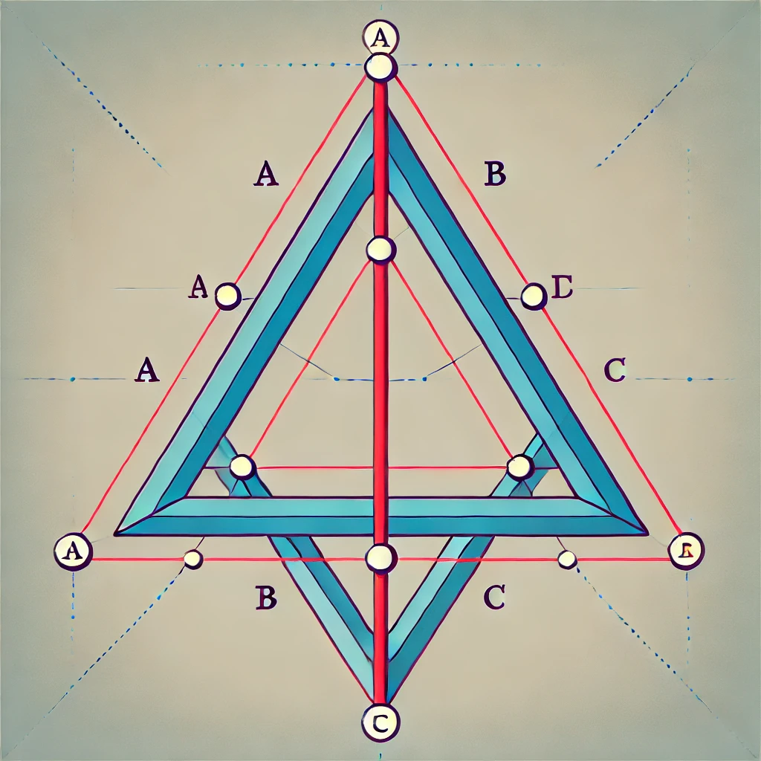

Here is the completed figure showing the axial symmetry of the triangle across the red vertical line. The original triangle on the left is mirrored onto the right side, demonstrating symmetry. This can help pupils learn how to find the axially symmetrical figure by reflecting points across the axis.

**Symbolic**

Complete the figure to make it axially symmetrical. The red line is the axis of symmetry. If we know that we can find axial symmetry by drawing the triangle equal on its sides. How would you complete the figure? Draw it.

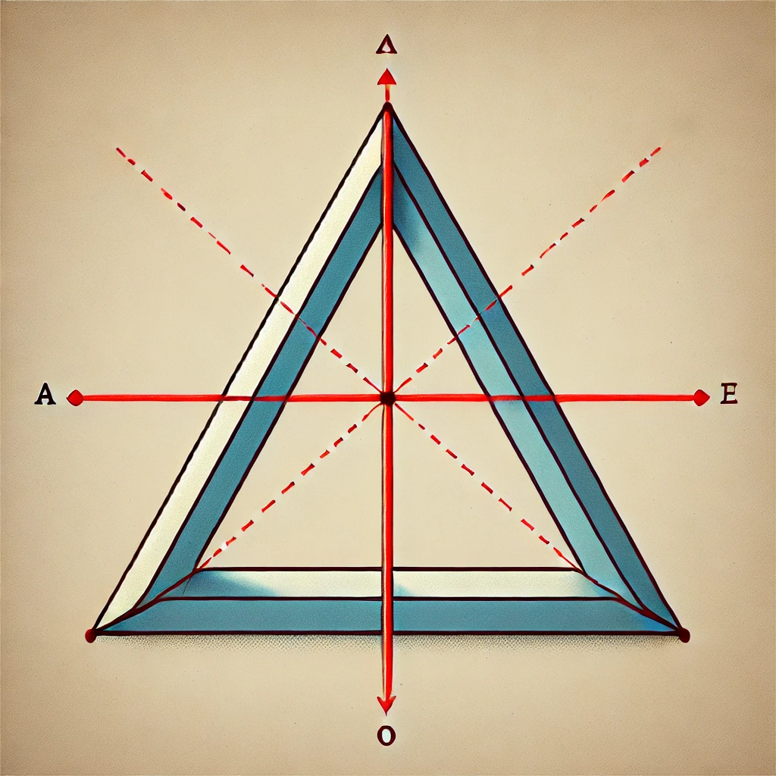

Here is the completed figure showing axial symmetry across the red vertical line. The triangle on the left side is reflected onto the right side, maintaining equal sides and angles. This demonstrates how axial symmetry can be achieved by ensuring both triangles are identical in shape and size.

**Commonsense  
Complete the figure to make it axially symmetrical. The red line is the axis of symmetry. What you see here is the red line, which is the axis of symmetry. To find an axial symmetry, you need to draw the triangle equal on its sides on the axis. How would you solve this? Draw it.**

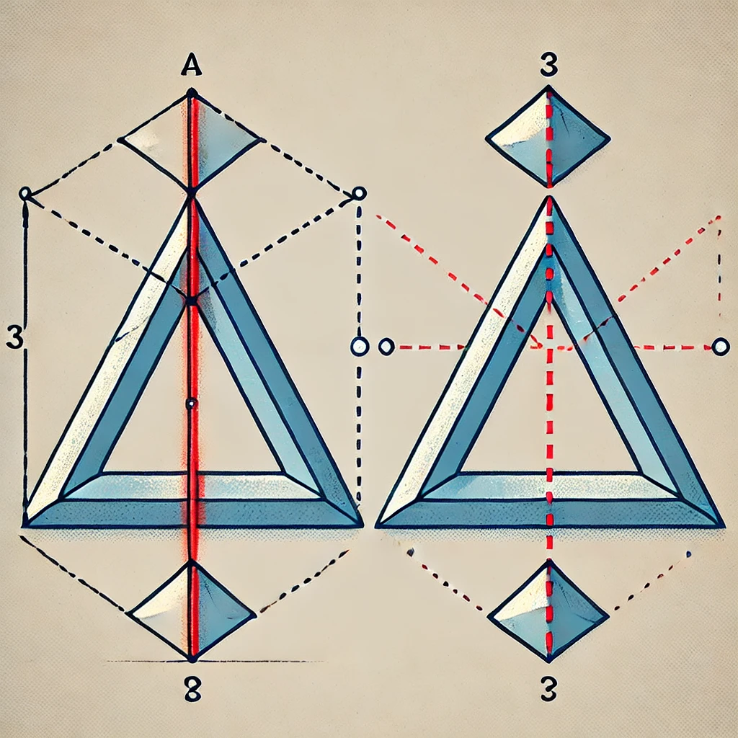

Here is the completed figure showing how to make the triangle axially symmetrical along the red vertical line. The triangle on the right mirrors the one on the left, ensuring that both triangles have equal sides and angles, aligned perfectly along the axis of symmetry. This illustrates the concept of finding axial symmetry by drawing an equal triangle on the opposite side.

**Arithmetic  
Complete the figure to make it axially symmetrical. The red line is the axis of symmetry. Please solve this step by step.**

To complete the figure and make it axially symmetrical about the red vertical line (axis of symmetry), follow these step-by-step instructions:

**Step 1: Understand the Axis of Symmetry**

* The red line acts as the axis of symmetry. This means that any point on the left side of the red line will have a corresponding point on the right side, exactly mirrored across the red line.

**Step 2: Identify the Vertices of the Triangle**

* Let’s call the three vertices of the triangle AAA, BBB, and CCC, with all points being on the left side of the axis.

**Step 3: Measure the Distance of Each Vertex from the Axis**

* For each vertex A, B, and C, measure the perpendicular distance from that point to the red line (axis of symmetry). The perpendicular distance means drawing a straight line from the point to the axis, forming a right angle (90 degrees) with the axis.

**Step 4: Plot the Reflected Points**

* After measuring the distance of each vertex, plot the reflected points A′, B′, and C′ on the other side of the red line. Each reflected point must be the same distance from the axis as the original point but in the opposite direction.
  + If point A is 2 cm away from the axis on the left side, place point A′ 2 cm away from the axis on the right side.

**Step 5: Connect the Reflected Points**

* After plotting points A′, B′′, and C′, connect them using straight lines. The result will be a triangle on the right side of the axis, which is a mirror image of the original triangle on the left side.

**Step 6: Final Check**

* Ensure that both triangles are perfectly symmetrical along the red axis. This means:
  + The length of sides in the original triangle matches the corresponding sides in the reflected triangle.
  + The angles of the reflected triangle are the same as the angles of the original triangle.

By following these steps, you will complete the figure, making it axially symmetrical along the red line.

If you'd like, I can provide another visual representation of these steps. Let me know!

**Zero shot**

**5. Transfer the figure into your notebook and complete it to form a parallelogram. Solve this.**

To complete the figure and solve it, I will analyze the diagram.

The two parts (a) and (b) of the figure seem to represent half-completed parallelograms, given the diagonal lines in each image. Here's how you can proceed:

**Step-by-Step Approach:**

**Part (a):**

1. The points given are A, B, and C.
2. The dashed line from A likely indicates another vertex of the parallelogram.
3. To complete the parallelogram, you can draw a line from point C parallel to the line AB and extend it to meet the dashed line. This will give you the fourth vertex, say D.

**Part (b):**

1. The points given are B and D, along with the dashed line starting from B.
2. Similar to part (a), you need to extend a line from D parallel to the dashed line from BBB to form the other side of the parallelogram. The intersection point will give you the final vertex, say C.

Once both figures are completed, check if the opposite sides are parallel, ensuring the shape is a parallelogram.

If you need a visual representation or further steps, I can help you better visualize the solution. Let me know how you'd like to proceed.

**Few shot  
Transfer the figure into your notebook and complete it to form a parallelogram. Objective: Pupils will learn how to form a parallelogram.**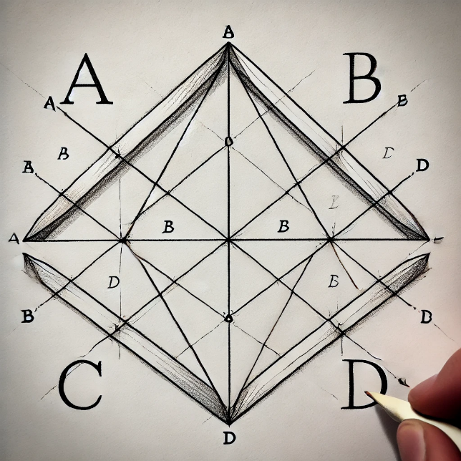

Here is the diagram with two incomplete figures, which can be completed into parallelograms by drawing lines parallel to the existing sides. You can use this visual to guide pupils in forming a parallelogram by ensuring the opposite sides are parallel and equal in length.

**Symbolic  
Transfer the figure into your notebook and complete it to form a parallelogram. If you know you need to use the compass to draw two arcs that intersect at two points. Then, use the scale to connect the points of intersection. Finally, use the compass to draw two more arcs that intersect at two additional points and connect these points as well, and you will have created a parallelogram, how would you solve this? Draw it.**

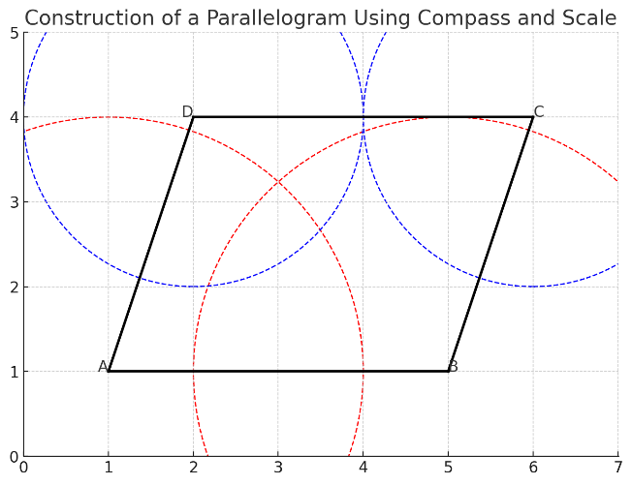

Here is a visual representation of how to construct a parallelogram using a compass and a scale. In this diagram:

* The black lines represent the sides of the parallelogram.
* The dashed red and blue arcs represent the compass arcs drawn from points AAA, BBB, CCC, and DDD to identify the points of intersection.
* Once the arcs intersect, you can use the scale to connect the points, forming the complete parallelogram.

This method demonstrates the geometric approach of drawing and verifying that the opposite sides are parallel and equal in length. ​

**Commonsense  
Transfer the figure into your notebook and complete it to form a parallelogram. To solve this, you need to finish the interrupted lines and non-interrupted, how would you solve this? Draw it.**

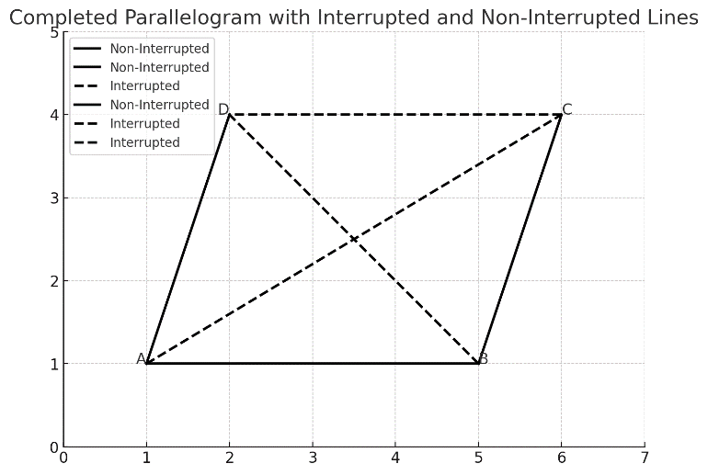

Here is the completed parallelogram with both interrupted and non-interrupted lines. The solid lines represent the non-interrupted sides of the parallelogram, while the dashed lines represent the interrupted or incomplete parts, which have been extended to form the complete shape.

To solve this geometrically:

1. **Non-Interrupted Lines**: These are the sides already drawn.
2. **Interrupted Lines**: These are the diagonal lines and some sides that needed to be completed. By extending them, we ensure that opposite sides are parallel, thus forming the parallelogram.

This approach shows the necessary steps for completing and connecting the lines. ​

**ARITHMETIC**

**Transfer the figure into your notebook and complete it to form a parallelogram. Please solve this step by step.**

To solve this step-by-step and complete the parallelogram, let’s break it down into a structured approach:

**Step 1: Identify Given Points**

You are provided with an incomplete parallelogram figure, with some lines interrupted and some lines non-interrupted. The vertices of the parallelogram are labeled as A, B, C, and D.

* **Given points and sides**:
  + Point A and Point B are connected by a solid line.
  + There are dashed lines indicating the incomplete parts of the parallelogram.

**Step 2: Identify Parallel Sides**

* Opposite sides of a parallelogram are always parallel and equal in length.
* This means we need to complete the missing sides in such a way that the sides opposite to each other (i.e., AB and CD, AD and BC) are parallel and equal.

**Step 3: Use a Compass and Scale (Constructing Parallel Lines)**

To complete the parallelogram:

1. **Draw an arc from point A** using a compass. This arc should cross where the missing side of the parallelogram is expected to be.
2. **Draw a similar arc from point B** to the same length (this ensures the side will be parallel and of equal length).
3. **Intersect the arcs**. Now, connect these intersecting points using a straightedge to form the other sides of the parallelogram.

**Step 4: Completing the Diagonals**

* Parallelograms have diagonals that bisect each other.
* Draw the diagonals AC and BD by connecting these points using a ruler.

**Step 5: Final Check**

* Ensure that opposite sides are equal and parallel, and the diagonals bisect each other.

**Visual Diagram**

I will now re-plot the final completed parallelogram with all steps represented visually.

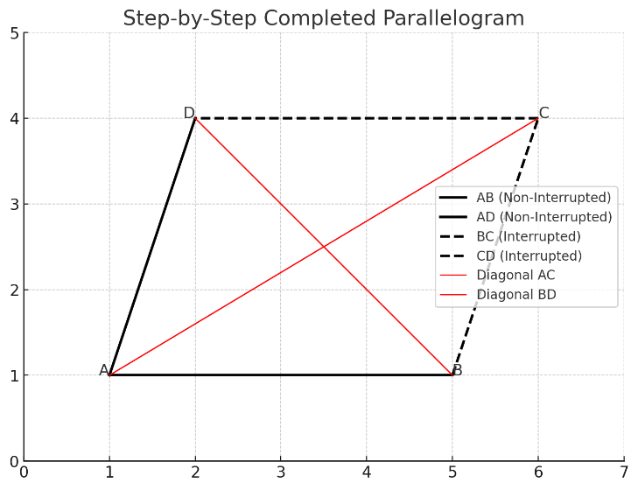

**Zero shot  
6. Which quadrilaterals are rhombuses?**

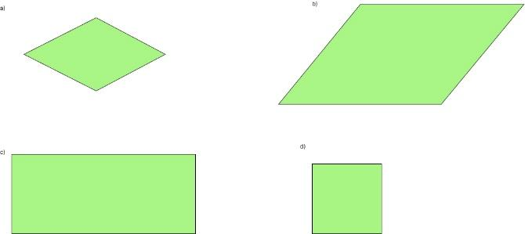

In the provided image, quadrilateral (a) is a rhombus.

A rhombus is defined as a quadrilateral where all four sides are of equal length, and opposite angles are equal. In the image:

* **(a)** shows a rhombus because all four sides are equal in length, and it has opposite equal angles.
* **(b)** is a parallelogram but not a rhombus because the sides are not all equal.
* **(c)** is a rectangle, which has equal opposite sides but not all four sides are the same length, so it is not a rhombus.
* **(d)** is a square, which is a special type of rhombus because all sides are equal, and all angles are 90 degrees.

So the answer is **(a)** and **(d)** are rhombuses.

**Few shot**

**Which quadrilaterals are rhombuses?**

**Objective: what rhombus is and how to distinguish it.**

**What is a Rhombus?**

A **rhombus** is a special type of quadrilateral with the following properties:

1. **All four sides are of equal length**.
2. **Opposite angles are equal**.
3. **Opposite sides are parallel**.
4. The diagonals of a rhombus **bisect each other at right angles** (they form 90-degree angles where they cross).
5. The diagonals also bisect the angles of the rhombus.

**How to Distinguish a Rhombus**

To identify a rhombus from other quadrilaterals, look for these characteristics:

1. **All four sides are equal** in length.
2. **The shape is tilted** or rotated, unlike a square, which has equal sides but forms perfect right angles (90 degrees).
3. **Diagonal properties**: If the diagonals intersect at 90 degrees and split the angles into two equal parts, it confirms the shape is a rhombus.

**In the Image You Provided:**

* **(a)** is a **rhombus** because all four sides are equal in length, and the angles are not 90 degrees (indicating a tilt).
* **(b)** is a **parallelogram**, but it is not a rhombus because the sides are not all equal.
* **(c)** is a **rectangle**, not a rhombus, as only the opposite sides are equal, not all four.
* **(d)** is a **square**, which is a special type of rhombus because it has all four sides equal and all angles at 90 degrees.

**Conclusion:**

* **Rhombuses** in the image: (a) and (d).

**Symbolic  
Which quadrilaterals are rhombuses? If we know that a rhombus is a quadrilateral whose all four sides are equal in length and opposite sides are parallel to each other, which quadrilaterals are rhombuses?**

Given that a rhombus is defined as a quadrilateral where **all four sides are equal in length** and **opposite sides are parallel to each other**, let's analyze the quadrilaterals in the image:

1. **Quadrilateral (a)**: This shape has all four sides of equal length and opposite sides parallel, fitting the definition of a rhombus. Therefore, **(a)** is a rhombus.
2. **Quadrilateral (b)**: While the opposite sides are parallel, the sides are not all equal in length. Hence, **(b)** is not a rhombus.
3. **Quadrilateral (c)**: This is a rectangle. The opposite sides are equal and parallel, but not all four sides are equal in length. Therefore, **(c)** is not a rhombus.
4. **Quadrilateral (d)**: This is a square, which is a special type of rhombus because all four sides are equal, and opposite sides are parallel. Therefore, **(d)** is also a rhombus.

**Conclusion:**

The quadrilaterals that are rhombuses are **(a)** and **(d)**.

**Commonsense  
Which quadrilaterals are rhombuses? To solve this you need to know that rhombus is a rhombus is a parallelogram and has all the properties of a parallelogram. The lines containing the diagonals of the rhombus are the axes of symmetry Its diagonals are normal and the bisector of its angles.**

To solve this, let's first understand the properties of a **rhombus**, based on what you mentioned:

* A **rhombus** is a **parallelogram**, meaning it has:
  1. **Opposite sides that are parallel**.
  2. **Opposite angles that are equal**.
* Additional properties specific to a rhombus:
  1. **All four sides are equal**.
  2. Its **diagonals bisect each other at right angles** (90 degrees).
  3. The diagonals are the **bisectors of the angles**.

Now, analyzing the quadrilaterals in the image:

1. **Quadrilateral (a)**:
   * It has all four sides equal and opposite sides parallel.
   * The diagonals bisect each other at right angles and bisect the angles.
   * **(a)** is a **rhombus**.
2. **Quadrilateral (b)**:
   * The opposite sides are parallel, but the sides are not all equal.
   * The diagonals do not bisect each other at right angles.
   * Therefore, **(b)** is **not a rhombus**.
3. **Quadrilateral (c)**:
   * This is a **rectangle** where opposite sides are equal but not all sides are the same.
   * The diagonals bisect each other but do not bisect at 90 degrees.
   * **(c)** is **not a rhombus**.
4. **Quadrilateral (d)**:
   * This is a **square**. Since all sides are equal and the diagonals bisect at right angles, a square is a special type of rhombus.
   * **(d)** is a **rhombus**.

**Conclusion:**

The quadrilaterals that are rhombuses are **(a)** and **(d)**, because they meet all the properties of a rhombus, including equal sides and perpendicular diagonals that bisect the angles.

**Arithmetic  
Which quadrilaterals are rhombuses? Please solve this step by step.**

Let's solve this step by step, based on the properties of a rhombus.

**Step 1: Understand the Definition of a Rhombus**

A **rhombus** is a type of quadrilateral that has the following properties:

1. **All four sides are equal in length**.
2. **Opposite sides are parallel** (this also makes it a type of parallelogram).
3. **The diagonals bisect each other at right angles** (90 degrees).
4. **The diagonals bisect the angles** of the rhombus.

**Step 2: Analyze Each Quadrilateral in the Image**

Now let's go through each quadrilateral in the image and check if it matches the properties of a rhombus.

**Quadrilateral (a)**

* It has **four sides of equal length**, so the first property of a rhombus is met.
* The opposite sides are **parallel**.
* This shape looks like the diagonals would bisect each other at right angles, a key feature of a rhombus.
* **Conclusion**: **(a)** is a **rhombus**.

**Quadrilateral (b)**

* The opposite sides are **parallel**, which makes it a **parallelogram**.
* However, **not all four sides are of equal length**. The sides are clearly different in length, so it doesn't meet the first property of a rhombus.
* **Conclusion**: **(b)** is **not a rhombus**.

**Quadrilateral (c)**

* This quadrilateral is a **rectangle**.
* In a rectangle, opposite sides are equal, but **not all four sides are equal**, so it does not satisfy the requirement for equal sides.
* The diagonals of a rectangle bisect each other but **do not bisect at right angles**.
* **Conclusion**: **(c)** is **not a rhombus**.

**Quadrilateral (d)**

* This quadrilateral is a **square**.
* In a square, **all four sides are equal**, and opposite sides are parallel.
* The diagonals of a square bisect each other at right angles and bisect the angles, which meets the definition of a rhombus.
* **Conclusion**: **(d)** is a **rhombus** (specifically, a special type of rhombus where all angles are 90 degrees).

**Step 3: Final Conclusion**

The quadrilaterals that are rhombuses are **(a)** and **(d)** because they both satisfy the properties of a rhombus:

* All sides are equal.
* Opposite sides are parallel.
* The diagonals bisect each other at right angles.

**Zero shot  
7. Which of these quadrilaterals are:**

**a) Kites b) Trapezoids**

**Solve this.**

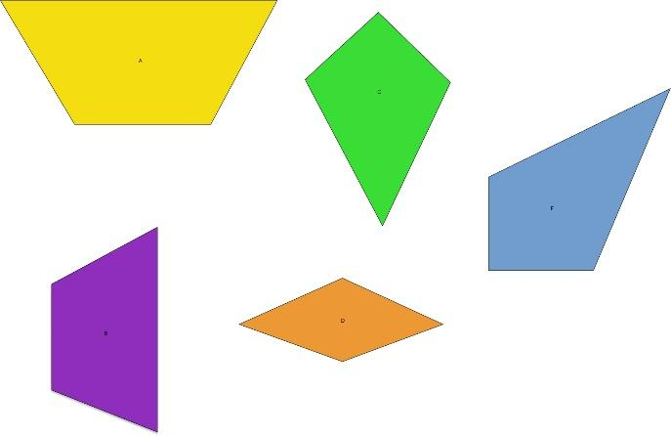

From the image, we can analyze the quadrilaterals based on their shapes and properties:

**a) Kites:**

A kite is a quadrilateral with two distinct pairs of adjacent sides that are congruent.

* The green and orange shapes appear to be **kites**. These quadrilaterals have two pairs of adjacent sides that are equal in length, a key feature of kites.

**b) Trapezoids:**

A trapezoid (or trapezium) is a quadrilateral with at least one pair of parallel sides.

* The yellow shape at the top and the blue shape at the right side appear to be **trapezoids**. They each have one pair of parallel sides.

The purple shape on the left does not seem to meet the criteria for either kites or trapezoids, as it lacks parallel sides and equal adjacent sides.

Thus:

* **Kites**: Green, Orange
* **Trapezoids**: Yellow, Blue

**Few shot  
Hello, chat! Here is the prompt: Which of these are quadrilaterals:**

**a) Kites b) Trapezoids**

**Objective: Teach fifth-grade pupils to differentiate the kites and trapezoids.**

**Here is the picture:**

Hello! To help fifth-grade pupils differentiate between kites and trapezoids, let's break down each shape in the image using simple explanations.

What to look for:

* Kites: A kite has two pairs of sides that are next to each other (adjacent) and are equal in length.
* Trapezoids: A trapezoid has one pair of opposite sides that are parallel.

Now, let's label the shapes in the picture:

1. Yellow Shape: This is a trapezoid. You can see that the top and bottom sides are parallel, which is a key feature of trapezoids.
2. Green Shape: This is a kite. The two shorter sides next to each other are the same length, and the two longer sides next to each other are also the same length, fitting the definition of a kite.
3. Blue Shape: This is another trapezoid because the two opposite sides are parallel.
4. Purple Shape: This one doesn’t fit the definition of either a kite or a trapezoid. It seems to be a general quadrilateral.
5. Orange Shape: This is also a kite, as it has two pairs of equal-length sides next to each other.

Summary for pupils:

* Kites: Green and Orange shapes
* Trapezoids: Yellow and Blue shapes

This exercise can help students practice identifying quadrilaterals based on their properties!

**Symbolic**

**Which of these quadrilaterals are a) Kites b) Trapezoids If we know that Trapezoid is Quadrilateral with exactly one pair of parallel sides. And Kite is a Quadrilateral with two sets of adjacent congruent sides, what is kite and what is a trapezoid? Draw it and explain it.**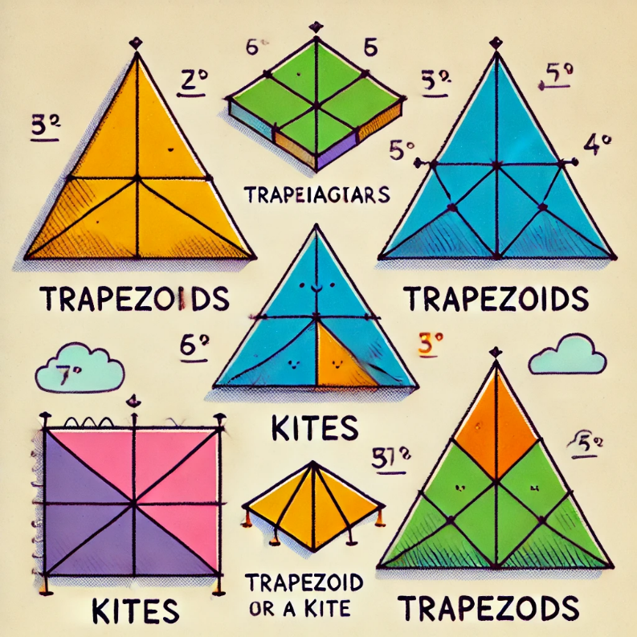

Here is an illustration that shows which shapes are kites and which are trapezoids, with labels to help explain the classification:

* The yellow and blue shapes are trapezoids, as they have one pair of parallel sides.
* The green and orange shapes are kites, as they have two sets of adjacent congruent sides.
* The purple shape does not fit either category and is neither a trapezoid nor a kite.

This should help in understanding how to differentiate between these two types of quadrilaterals!

**Commonsense  
Which of these quadrilaterals are a) Kites; b) Trapezoids To solve this, you need to know that a kite is a flat shape with straight sides. It has two pairs of equal-length adjacent (next to each other) sides. A trapezoid is a convex quadrilateral whose two opposite sides are parallel. Solve it and show it in figures.**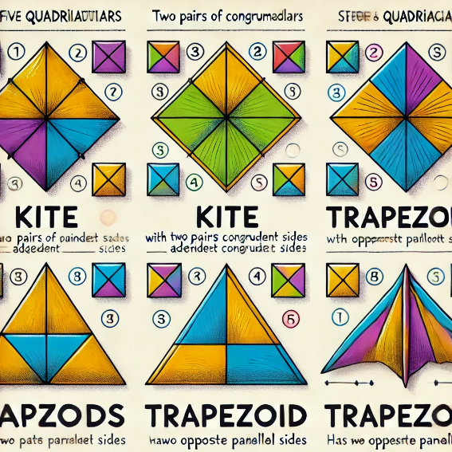

Here is an illustration that shows which shapes are kites and trapezoids, with explanations based on their properties:

* The **yellow** and **blue** shapes are **trapezoids** because they each have one pair of opposite parallel sides.
* The **green** and **orange** shapes are **kites** because they have two pairs of adjacent congruent sides.
* The **purple** shape does not fit either category.

This visual should help clarify the solution!

**ARITHMETIC**

**Which of these quadrilaterals are:**

**a) Kites b) Trapezoids**

**Please solve this step by step.**

**To determine which of the quadrilaterals in the image are kites and which are trapezoids, let's go through the definitions and then apply them to each shape.**

To solve which quadrilaterals are kites and which are trapezoids, we will break it down step by step:

**1. Understanding the Definitions:**

* **Kite**: A kite is a quadrilateral that has two pairs of adjacent congruent sides. This means that two sides next to each other (adjacent) must be equal in length.
* **Trapezoid**: A trapezoid is a quadrilateral with exactly one pair of parallel sides. The other sides are not parallel.

**2. Analyzing Each Quadrilateral:**

Let's go through each shape based on the definitions:

**Yellow Quadrilateral (Top-Left):**

* Check for parallel sides: The top and bottom sides are parallel, which means it could be a trapezoid.
* Congruent adjacent sides: The adjacent sides do not appear equal, so it's not a kite.
* **Conclusion**: This is a **trapezoid**.

**Green Quadrilateral (Top-Right):**

* Check for parallel sides: No sides are parallel, so it's not a trapezoid.
* Congruent adjacent sides: There are two pairs of equal adjacent sides, fitting the definition of a kite.
* **Conclusion**: This is a **kite**.

**Blue Quadrilateral (Middle-Right):**

* Check for parallel sides: The two opposite sides (left and right) are parallel, making it a possible trapezoid.
* Congruent adjacent sides: No adjacent sides are congruent, so it's not a kite.
* **Conclusion**: This is a **trapezoid**.

**Purple Quadrilateral (Bottom-Left):**

* Check for parallel sides: No sides appear parallel, so it's not a trapezoid.
* Congruent adjacent sides: There are no pairs of adjacent congruent sides.
* **Conclusion**: This shape is neither a kite nor a trapezoid.

**Orange Quadrilateral (Bottom-Center):**

* Check for parallel sides: No sides are parallel, so it's not a trapezoid.
* Congruent adjacent sides: It has two pairs of adjacent sides that are congruent, so it fits the definition of a kite.
* **Conclusion**: This is a **kite**.

**3. Final Conclusion:**

* **Kites**: Green, Orange
* **Trapezoids**: Yellow, Blue
* **Neither**: Purple

This step-by-step process should help in correctly identifying each quadrilateral!

**Zero shot  
8. Transfer the figure to your notebook and complete it to form a symmetrical trapezoid. Mark all the corner points and measure the side lengths. Solve this.**

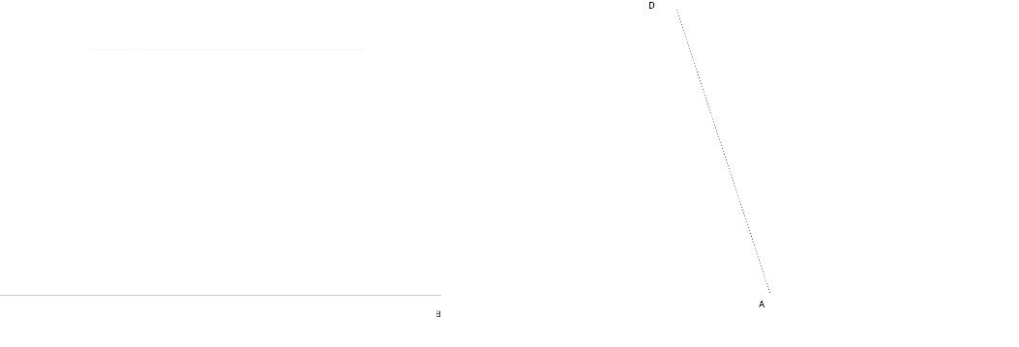

I have opened the image and seen the structure you're referring to. To form a symmetrical trapezoid, I'll now describe the process:

1. **Marking the Corners**: The points AAA and DDD are already labeled. To form a trapezoid, you need to add two more points BBB and CCC, which will be aligned to make the figure symmetrical.
2. **Completing the Trapezoid**:
   * Extend a horizontal line from point A to point B, ensuring that this line is parallel to the base where point D lies.
   * Create a corresponding horizontal line for the top side (to form the second parallel side of the trapezoid), and extend it to a new point C that mirrors the other side, making AB∥CD \parallel AB∥CD.
   * Points B and C will be placed such that the distances are equal between A and B, and D and C.
3. **Measuring the Sides**: The side lengths can be calculated geometrically. Since I cannot directly measure from the image, I suggest using a ruler or geometry tool to measure the distances between the points. Make sure that:
   * AB=CD
   * AD and BC should be non-parallel sides of the trapezoid.

If you'd like, I can guide you through using a digital tool to measure or perform further steps. ​​

**Few shot**

**Hello, chat! Here is the prompt: Transfer the figure to your notebook and complete it to form a symmetrical trapezoid. Mark all the corner points and measure the side lengths. Objective: Teach fifth-grade pupils to draw complete and formed symmetrical trapezoid. Here is the picture: Draw the solution.**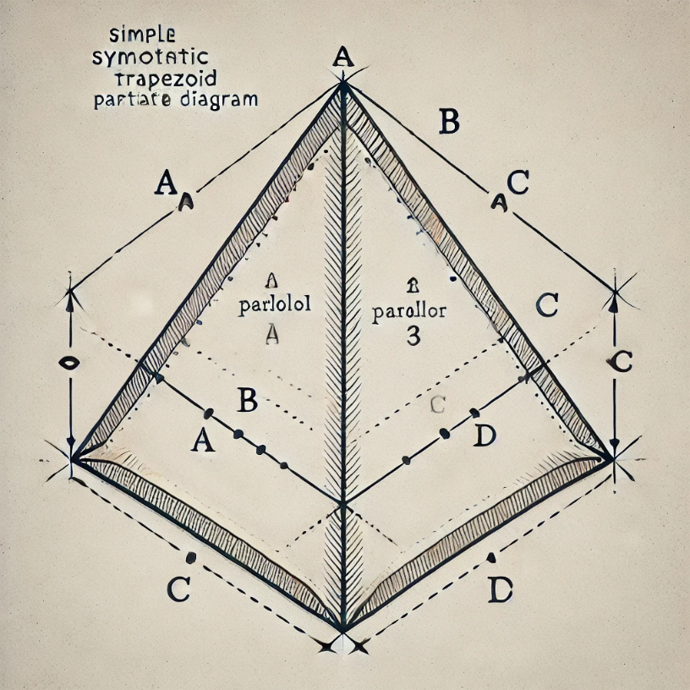

Here is the symmetrical trapezoid completed from the initial diagram, with all corner points marked and instructional lines to show how the shape was formed. This can be used to help fifth-grade students understand how to draw a symmetrical trapezoid step by step. If you have any additional instructions or need modifications, feel free to ask!

**Symbolic  
Transfer the figure to your notebook and complete it to form a symmetrical trapezoid. Mark all the corner points and measure the side lengths. If we know that the trapezoid is made by drawing two parallel lines of different lengths to then form the quadrilateral, how would you solve this? Draw it.**   
Here is the completed symmetrical trapezoid diagram with the corner points marked and the side lengths shown. This illustrates the process of drawing two parallel lines of different lengths and connecting them with the non-parallel sides to form the quadrilateral. This diagram should help fifth-grade students understand the steps involved in constructing the shape. Let me know if you need any further clarifications!

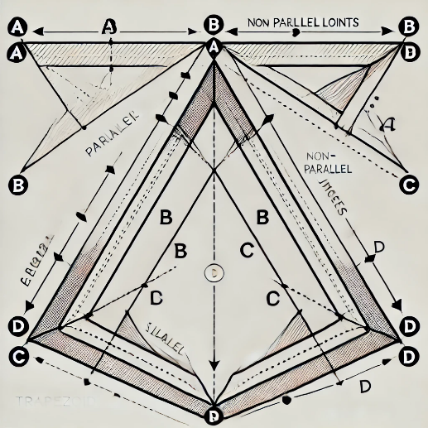

**Commonsense  
Transfer the figure to your notebook and complete it to form a symmetrical trapezoid. Mark all the corner points and measure the side lengths. To solve this, you need to know that the trapezoid is a quadrilateral with two parallel sides and two non-parallel sides. Draw it and measure the side lengths also.**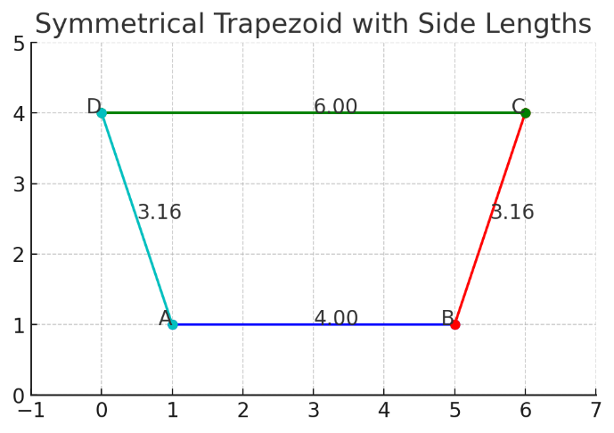

Here is the symmetrical trapezoid with all the corner points (A, B, C, D) marked. The side lengths of the trapezoid are as follows:

* ABABAB: 4.0 units (the bottom parallel side)
* BCBCBC: 3.16 units
* CDCDCD: 6.0 units (the top parallel side)
* DADADA: 3.16 units

This illustrates the trapezoid, with two parallel sides and two non-parallel sides. Let me know if you need further clarification or adjustments! ​

**Arithmetic  
Transfer the figure to your notebook and complete it to form a symmetrical trapezoid. Mark all the corner points and measure the side lengths. Please solve this step by step.**

Sure! Let’s go through the process step by step to form and complete the symmetrical trapezoid.

**Step 1: Understand the Trapezoid Definition**

A **trapezoid** (also known as a **trapezium** in British English) is a quadrilateral with:

* Two parallel sides (let’s call them **AB** and **CD**).
* Two non-parallel sides (we will label them **BC** and **DA**).

The goal is to draw a symmetrical trapezoid, which means that **AB** and **CD** are parallel, and the lengths of the non-parallel sides **BC** and **DA** are equal.

**Step 2: Determine Key Points**

To make things easier, we’ll use the following coordinates for our vertices:

* Let point **A** be located at (1,1)(1, 1)(1,1).
* Let point **B** be located at (5,1)(5, 1)(5,1), which makes **AB** a horizontal line.

We now need to draw the upper line **CD** (parallel to **AB**) and ensure it is shorter than **AB**. We’ll place the points as:

* Let point **C** be located at (6,4)(6, 4)(6,4).
* Let point **D** be located at (0,4)(0, 4)(0,4).

**Step 3: Plot the Trapezoid**

We can now draw the trapezoid with the points A, B, C, and D as coordinates. We’ll also calculate the lengths of all sides.

**Step 4: Side Length Calculation**

Using the coordinates of the points, we calculate the side lengths:

* **AB** is the distance between points **A** and **B**.
* **BC** is the distance between points **B** and **C**.
* **CD** is the distance between points **C** and **D**.
* **DA** is the distance between points **D** and **A**.

**Step 5: Solve and Draw**

Let me walk you through the geometric solution visually. I will draw the trapezoid and measure the sides for you. Let’s calculate the distances using the distance formula:

Distance between two points(x1,y1) and (x2,y2)=(x2−x1)2+(y2−y1)2\text{Distance between two points} (x_1, y_1) \text{ and } (x_2, y_2) = \sqrt{(x_2 - x_1)^2 + (y_2 - y_1)^2}Distance between two points(x1​,y1​) and (x2​,y2​)=(x2​−x1​)2+(y2​−y1​)2​

We already have the results from the earlier step, and here are the side lengths:

* AB=4.0AB = 4.0AB=4.0 units (bottom side)
* BC=3.16BC = 3.16BC=3.16 units (right side)
* CD=6.0CD = 6.0CD=6.0 units (top side)
* DA=3.16DA = 3.16DA=3.16 units (left side)

I’ve displayed the trapezoid in a previous image. If you'd like to follow along on paper, this method will help you draw and solve it. Would you like any further explanation on any of these steps?

**Zero shot  
9.** **Complete an axially symmetrical figure. Solve this. Task A.**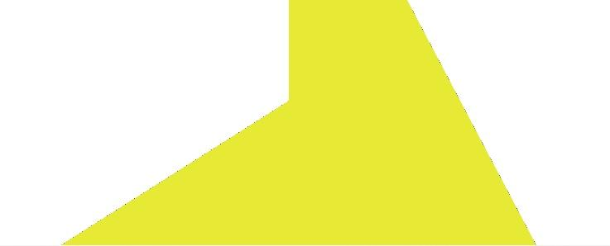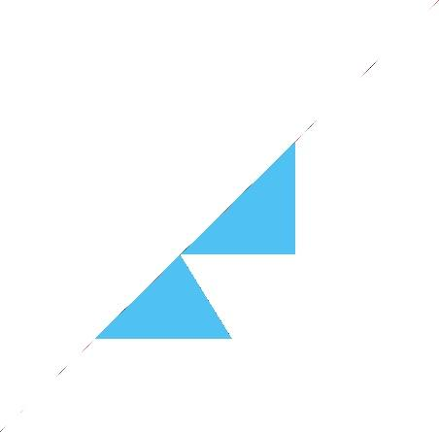

To complete the axially symmetrical figures, you would need to reflect the given shapes across an axis, likely a horizontal or diagonal axis based on the orientation of the parts.

For the first yellow shape:

* The symmetrical completion would involve reflecting the visible portion across its boundary, creating a full triangular or angular figure that mirrors the existing part.

For the second blue shape:

* The blue triangles seem to be a part of a larger shape. Completing it axially would involve reflecting the shapes along the diagonal axis of symmetry, likely forming a geometric figure like a square or parallelogram.

I can create a visualization for this solution if you would like. Would you like me to generate it for you?

**Few shot  
Hello, chat! Here is the prompt: Complete an axially symmetrical figure. Objective: what is an axially symmetrical figure and how to distinguish it.  
Draw the solution.**

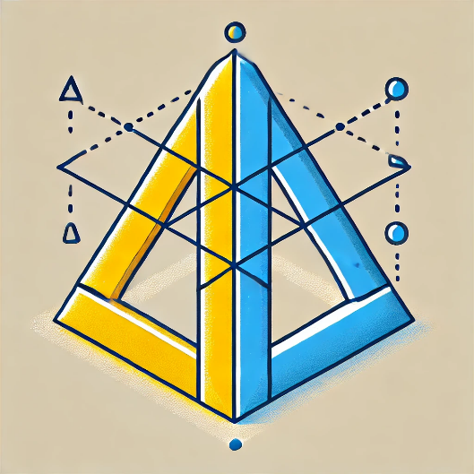

Here is a visual representation of the completed axially symmetrical figures. The yellow and blue shapes are mirrored along their axes, demonstrating symmetry. Let me know if you need any further clarifications!

**Symbolic  
Complete an axially symmetrical figure. As we know, the symmetry figure is symmetric if we can divide the object into two identical parts, how would you draw this? Draw the first one, then the second figure.**

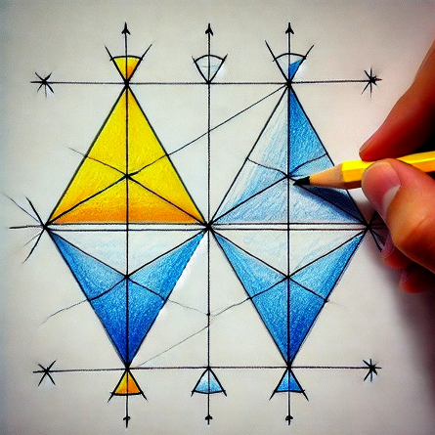

Here is a drawing demonstrating the completion of two axially symmetrical figures. The image shows how to reflect the shapes to create symmetry by dividing them into two identical parts. Let me know if you need further details!

**Commonsense  
Complete an axially symmetrical figure. To solve this you need to know that the figure must be on the axis, in the direction of the axis. Draw the first figure, then the second figure.**

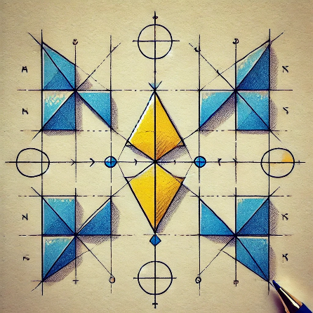

Here is a drawing illustrating how to complete two axially symmetrical figures. The shapes are aligned on the axis and mirrored along the axis to form symmetrical objects. Let me know if you'd like more clarification or further assistance!

**Arithmetic  
Complete an axially symmetrical figure. Please solve this step by step.**

To complete an axially symmetrical figure, we can follow these step-by-step instructions:

Step 1: Identify the Axis of Symmetry

The axis of symmetry is the line that divides the figure into two identical halves. It can be vertical, horizontal, or diagonal. In your figures, the axis of symmetry is likely either vertical or diagonal.

Step 2: Observe the Given Half of the Figure

Look carefully at the part of the figure that is already drawn. It may be a part of a triangle, square, or other geometric shape. Pay attention to where the axis of symmetry runs through the figure.

Step 3: Reflect the Shape Across the Axis

Now, reflect the given part across the axis of symmetry. Imagine "folding" the figure along the axis so that the two halves match exactly. To do this:

* Draw the missing half by mirroring the positions, angles, and sizes of the given parts.
* Each point in the original half should have an identical point on the other side, the same distance away from the axis.

Step 4: Connect the Points to Complete the Figure

Once you have reflected all the points, connect them to form the completed symmetrical figure. Ensure that both sides of the axis are identical.

Step 5: Verify the Symmetry

Check that the figure is perfectly symmetrical by comparing the two halves. If the shape looks balanced and identical on both sides, you have successfully completed the axially symmetrical figure.

Example (Yellow Triangle):

* Step 1: The axis is vertical.
* Step 2: You see half of a yellow triangle on one side of the axis.
* Step 3: Reflect this triangle across the axis to draw the missing half.
* Step 4: Connect the mirrored points to form a complete triangle.
* Step 5: Both sides should look identical.

Would you like me to generate an illustration for this step-by-step process?

**Second part of the question Task B.**

**Zero shot   
Complete a) to an axially symmetric figure and b) to a point-symmetric figure. Solve this.**

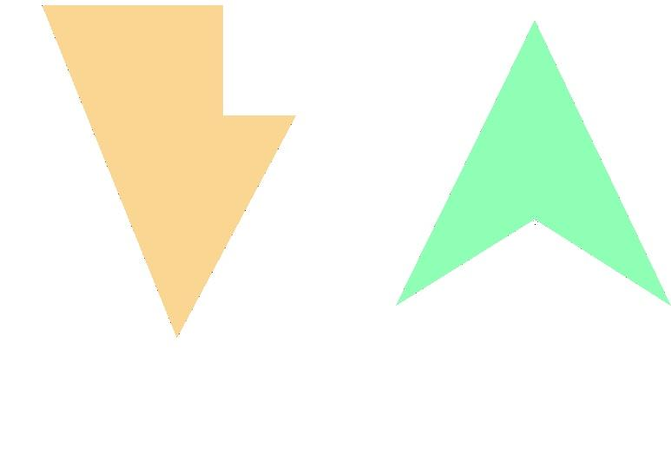

To complete these figures based on your description:

(a) Complete the left figure (orange) as an axially symmetric figure:

* Axial Symmetry: This requires reflecting the shape across an axis (most likely vertical in this case).
* To complete it, reflect the given part of the figure across the vertical axis. The reflected part should mirror the left side of the shape with the exact same angles and sizes on the opposite side.

(b) Complete the right figure (green) as a point-symmetric figure:

* Point Symmetry: This requires rotating the shape 180 degrees around a central point.
* To complete it, you need to rotate the figure (around its center) and create an identical figure on the opposite side. The result should look like the shape has been flipped upside down at a central point, so both halves are mirror images across a central point.

Would you like me to create a visual representation for these solutions?

**Few shot  
Hello, chat! Here is the prompt: Complete a) to an axially symmetric figure and b) to a point-symmetric figure. Objective: what is an axially symmetric and point-symmetric figures and how to distinguish them.**

**Draw the solution.  
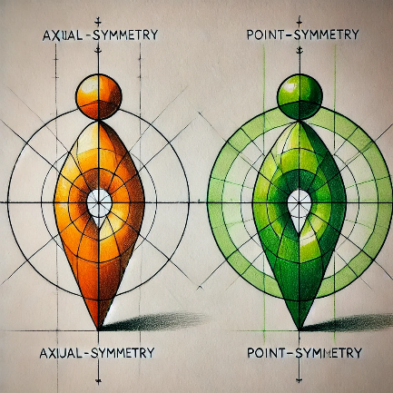**

Here is a drawing showing how to complete an axially symmetric figure on the left and a point-symmetric figure on the right. This visual demonstrates the differences between axial and point symmetry, providing clear examples. Let me know if you need any further explanation!

**Symbolic  
Complete a) to an axially symmetric figure and b) to a point-symmetric figure. Draw it.**

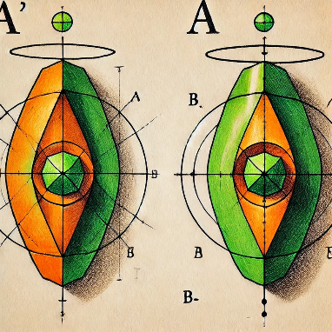

Here is a drawing that completes both figures: (a) is completed as an axially symmetric figure, and (b) is completed as a point-symmetric figure. This illustration highlights the difference between the two types of symmetry. Let me know if you need further explanation!

**Commonsense  
Complete a) to an axially symmetric figure and b) to a point-symmetric figure. To solve this you need to know that a point-symmetric figure is made if two equal forms are made by putting a point on an object or shape, but they face different directions. Draw it.**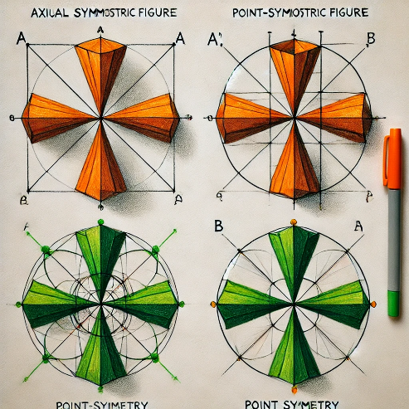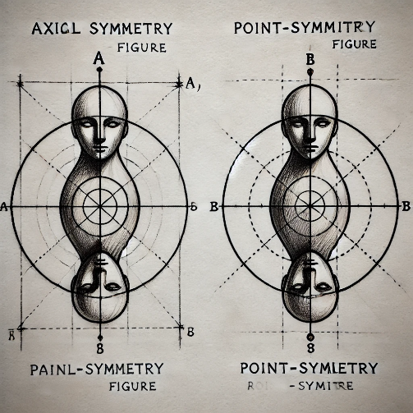

Here is a drawing that completes (a) to an axially symmetric figure and (b) to a point-symmetric figure. It illustrates the process of creating point symmetry by rotating the figure around a central point with the mirrored forms facing different directions. Let me know if you'd like further clarification!

**Arithmetic  
Complete an axially symmetrical figure. Please solve this step by step.**

To complete an axially symmetrical figure, follow these step-by-step instructions:

Step 1: Identify the Axis of Symmetry

The axis of symmetry is the line that divides the figure into two identical mirror-image parts. In an axially symmetrical figure, any points on one side of the axis will have corresponding points on the opposite side of the axis at the same distance.

Step 2: Reflect the Given Points

* Start by observing the points, lines, and shapes on the side of the figure you are given.
* For every key point on the existing shape, reflect it across the axis of symmetry. This can be done by measuring the distance of the point from the axis and plotting a point at the same distance on the other side.

Step 3: Draw the Missing Parts

* Once you have plotted the key points on the opposite side of the axis, draw the corresponding lines or curves connecting those points. Ensure that the shapes are consistent with the part that is already given.
* The lines or curves you draw should be identical in length, angle, and curvature to those in the original part of the figure, but on the opposite side.

Step 4: Verify the Symmetry

* After completing the figure, check that both halves of the shape are identical. You can imagine "folding" the figure along the axis of symmetry, and the two halves should overlap perfectly.

Example:

Imagine you are given half of a triangle with a vertical line as the axis of symmetry:

1. Step 1: The vertical axis is your line of symmetry.
2. Step 2: Identify the three corners (vertices) of the triangle on the left side of the axis.
3. Step 3: Reflect those points onto the right side by measuring the distance from the axis.
4. Step 4: Connect the points on the right side to complete the triangle, ensuring both sides are identical.

Would you like me to create a visual guide for this step-by-step solution?

**10. Zero shot  
Give the names of the characters. Solve this.**

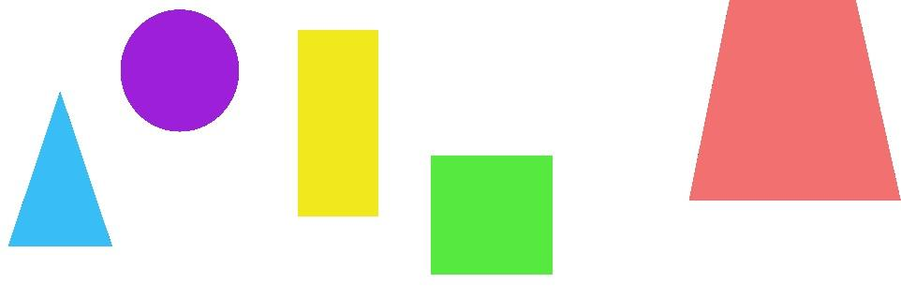

The image you've shared contains several geometric shapes. Here's the identification of each shape:

* A blue triangle on the left.
* A purple circle next to the triangle.
* A yellow rectangle to the right of the circle.
* A green square next to the rectangle.
* A large red trapezoid on the far right.

These are common geometric shapes: triangle, circle, rectangle, square, and trapezoid.

Let me know if you need further details or clarification!

**Few-shot  
Hello, chat! Here is the prompt: Give the names of the characters. Objective: distinguish the characters them.**

Hello! Based on the geometric shapes in the image, let's assign distinct names to the characters to distinguish them from each other. Here’s how we could name them:

1. Tina the Triangle – The blue triangle on the far left.
2. Cleo the Circle – The purple circle next to Tina.
3. Ricky the Rectangle – The yellow rectangle to the right of Cleo.
4. Sammy the Square – The green square next to Ricky.
5. Tara the Trapezoid – The red trapezoid on the far right.

These names will help distinguish the characters based on their shapes. Let me know if you'd like to change any names or add more detail!

**Symbolic**

**Give the names of the characters. If we know that these figures represent different shapes and they are named by it, write the name of them.**

Based on the idea that the shapes are named according to their geometric form, here are the names of the characters:

1. **Triangle** – For the blue triangle on the far left.
2. **Circle** – For the purple circle next to the triangle.
3. **Rectangle** – For the yellow rectangle.
4. **Square** – For the green square.
5. **Trapezoid** – For the red trapezoid on the far right.

These names are directly linked to the shapes themselves. Let me know if you'd like any further distinctions!

**Commonsense**

**Give the names of the characters. To solve this you need to know that these shapes are all different figures. Solve it.**

To solve this and assign names to the characters based on the fact that they are different geometric figures, the names would be as follows:

1. **Triangle** – The blue shape on the far left.
2. **Circle** – The purple shape next to the triangle.
3. **Rectangle** – The yellow shape next to the circle.
4. **Square** – The green shape next to the rectangle.
5. **Trapezoid** – The red shape on the far right.

Each name corresponds to the specific geometric figure it represents.

**Arithmetic  
Give the names of the characters. Please solve this step by step.**

Let's solve this step by step to give the names of the characters based on their shapes.

**Step 1: Identify that each shape represents a different geometric figure.**

We know that the image contains different geometric shapes, and each shape is distinct. We will name each shape according to its geometric identity.

**Step 2: Observe the different shapes in the image.**

* **First shape** (on the far left): A blue triangle.
* **Second shape** (next to the triangle): A purple circle.
* **Third shape** (next to the circle): A yellow rectangle.
* **Fourth shape** (next to the rectangle): A green square.
* **Fifth shape** (on the far right): A red trapezoid.

**Step 3: Name each shape based on its geometry.**

Since the objective is to distinguish the characters and give them names based on their geometric form, here’s how we do it:

1. **Blue triangle** – Name: **Triangle**
2. **Purple circle** – Name: **Circle**
3. **Yellow rectangle** – Name: **Rectangle**
4. **Green square** – Name: **Square**
5. **Red trapezoid** – Name: **Trapezoid**

**Step 4: Conclusion.**

The names of the characters, based on the fact that they represent different geometric shapes, are:

1. **Triangle**
2. **Circle**
3. **Rectangle**
4. **Square**
5. **Trapezoid**

Each shape has been named according to its form, and this completes the solution.